Modelling Heart Disease with Logistic Regression and Penalized Methods

- Data description and preprocessing
I first treated five variables as continuous predictors: age, trestbps (resting blood pressure), chol (serum cholesterol), thalach (maximum heart rate achieved), and oldpeak (ST depression). I then treated the remaining predictors as categorical: sex (0 = female, 1 = male), cp (chest pain type), fbs (fasting blood sugar > 120 mg/dl), restecg (resting ECG results), exang (exercise-induced angina), slope (slope of peak exercise ST segment), thal (thalassemia/defect type), clinic(Cleveland/Hungary/Switzerland), and ca (number of major vessels). In the training data, the prevalence of heart disease was approximately 50%, so the classes were somewhat balanced.
Some continuous variables contained physiologically implausible zeros, particularly chol and trestbps. In both the training and test sets, I replaced zeros in these columns with missing values (NaN). For continuous predictors, missing values were imputed using the median of the corresponding variable in the training data. For categorical predictors, missing values were imputed with the most frequent category (mode) in the training set. The same imputation values were later applied to the test set to avoid leaking information from test into training.
To reduce the influence of extreme outliers likely due to measurement or data entry error, I “winsorized” several continuous variables. Specifically, trestbps, chol, thalach, and oldpeak were clipped to the 1st and 99th percentile values calculated from the training data. I intentionally did not clip age to preserve the true range of patient ages. The same clipping thresholds were applied to the test set. After these steps, there were no remaining missing values in the cleaned dataset.

- Feature engineering and transformations
For modeling, I used a ColumnTransformer to apply appropriate preprocessing to continuous and categorical variables. Continuous predictors were standardized to have mean 0 and variance 1 using StandardScaler, while categorical variables were one-hot encoded using OneHotEncoder. This ensured that all predictors were on a comparable scale and that the logistic regression coefficients were interpretable on the standardized scale.
To allow for nonlinear relationships among the continuous predictors, I constructed an augmented feature set using degree-2 polynomial features. Using scikit-learn’s PolynomialFeatures, I generated all main effects, squared terms (e.g., oldpeak²), and pairwise interactions (e.g., trestbps × oldpeak) for the five continuous variables. These expanded features were then standardized and concatenated with the one-hot encoded categorical features. This polynomial expansion significantly increases the number of predictors, which motivated the use of penalized regression to control overfitting.

- Model fitting and selection
I started out trying several logistic regression models:
- Full unpenalized model. A logistic regression using all predictors (with polynomial expansion for the continuous variables) was fit using scikit-learn’s LogisticRegression without regularization. This served as a baseline but can be unstable given the high-dimensional feature space.
- Six-variable model via forward selection. Using Statsmodels’ GLM with a binomial family, I performed forward selection starting from no predictors and adding one variable at a time based on AIC. At each step, the candidate predictor that most reduced AIC was added, until six predictors had been selected. This yielded a relatively simple 6-variable model, which was then re-fit with standardized continuous variables and one-hot encoded categorical predictors.
- Linear elastic-net logistic regression. In this model, I used only the original predictors (no polynomial expansion) and applied StandardScaler + OneHotEncoder. The logistic regression used an elastic-net penalty, which combined L1 (lasso) and L2 (ridge) regularization. This model served as a penalized baseline with linear effects only.
- Polynomial elastic-net logistic regression. Finally, I fit an elastic-net logistic regression using the full degree-2 polynomial expansion of the continuous predictors together with one-hot encoded categorical variables. This model captured nonlinear and interaction effects but relies on regularization to prevent overfitting.
For the elastic-net models, I tuned the hyperparameters using 5-fold cross-validation on the training set, optimizing mean negative log-loss (equivalently, minimizing log-loss). I first examined a grid of regularization strengths (λ = 1/C) and then performed a two-dimensional grid search over (l1_ratio, C), where l1_ratio controls the mix between L1 and L2 penalties. The best combination had approximately l1_ratio ≈ 0.9 and C ≈ 0.43, indicating relatively strong and predominantly L1-type regularization. I then used these tuned values in the final elastic-net models. A plot of cross-validated log-loss versus λ is shown in Figure 1.

- Final model and performance
I compared models on the training data using accuracy, area under the ROC curve (AUC), Brier score, and log-loss. The 6-variable forward selection model performed reasonably well but was consistently outperformed by the penalized models. The linear and polynomial elastic-net models achieved very similar performance. The polynomial elastic-net model had slightly better AUC, Brier score, and log-loss, but the differences were extremely small, while accuracy was identical. This suggests that the added polynomial and interaction terms did not do much to improve discrimination or calibration beyond the linear effects.
Because of this, I selected the tuned linear elastic-net logistic regression as my final model: it provides competitive predictive performance while remaining simpler and more interpretable than the polynomial version. Table 1 summarizes the training performance of the main candidate models.

Table 1. Training performance of candidate models and
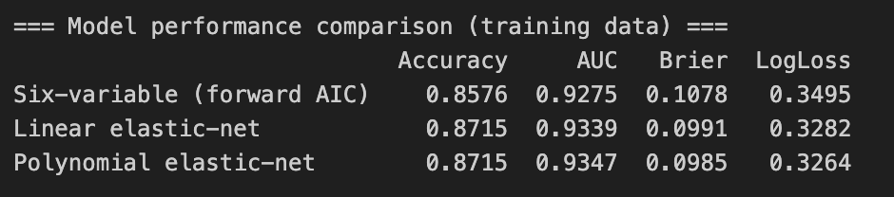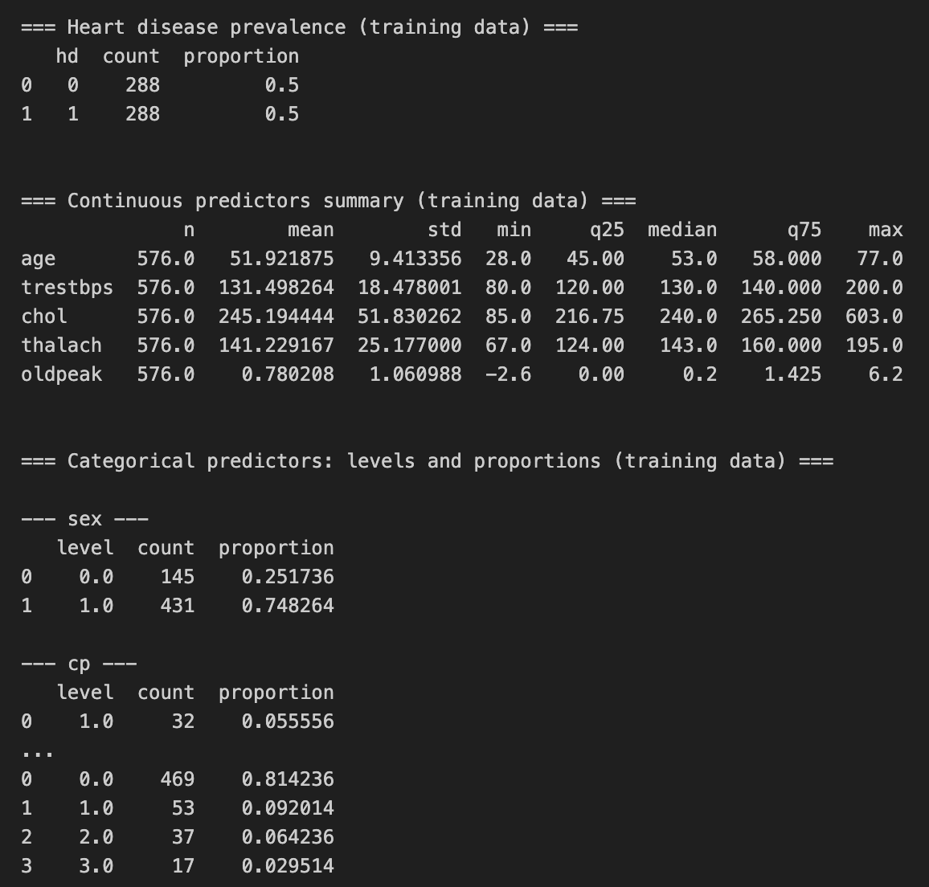

Figure 1. shows both the ROC curve for the final model on the training data, with an AUC of approximately 0.935 indicating strong discrimination between patients with and without heart disease and Five-fold cross-validated log-loss as a function of the regularization parameter λ for the elastic-net model.
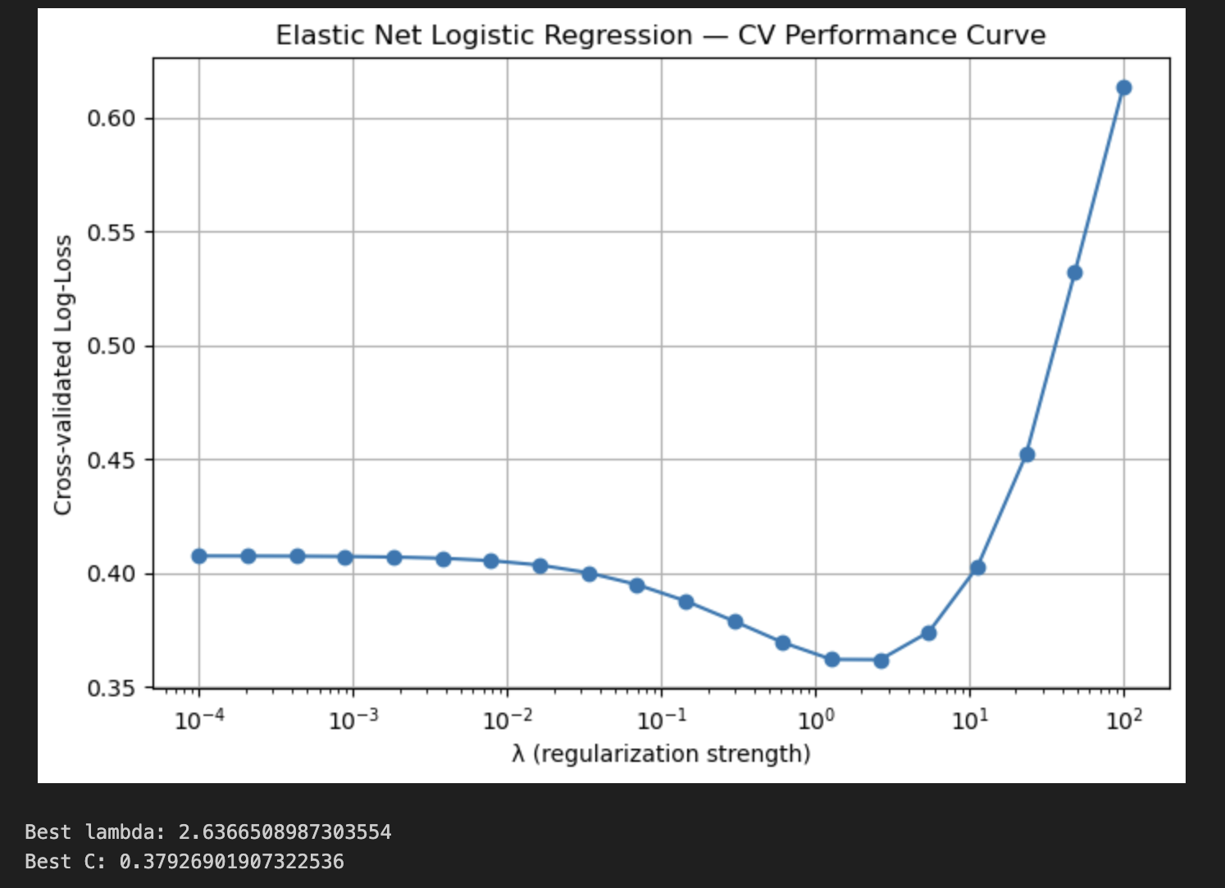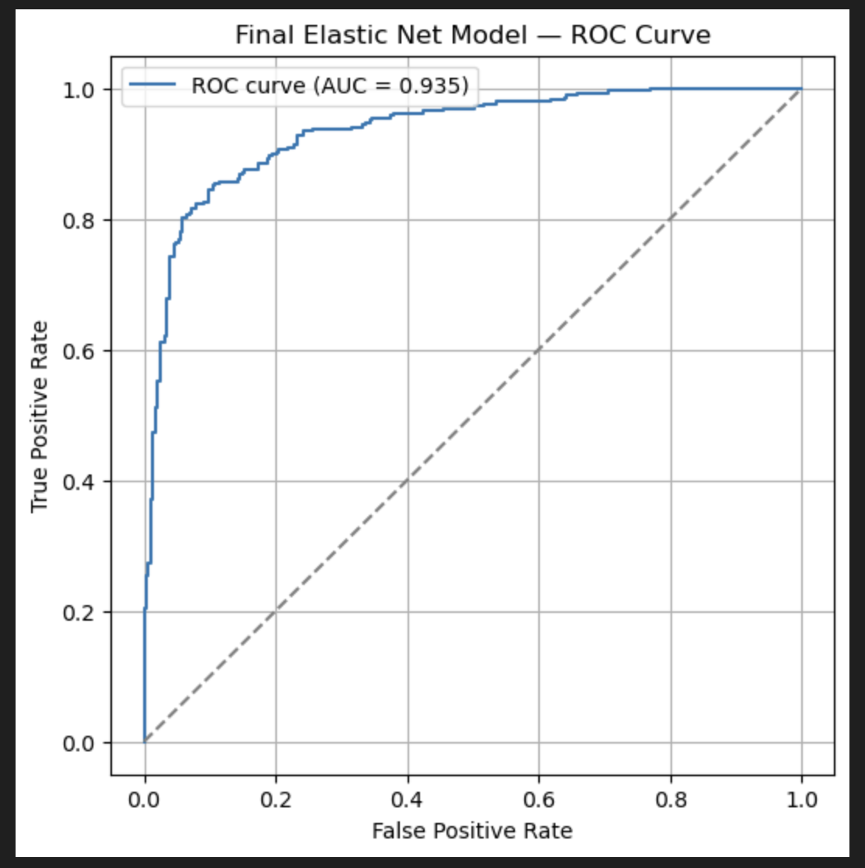

- Interpretation of the final model

The elastic-net penalty shrinks many coefficients toward zero and sets some exactly to zero, effectively performing variable selection. Examining the nonzero coefficients from the final linear model reveals several clinically plausible patterns. The indicator for the Switzerland clinic (clinic_swit) has a relatively large positive coefficient, suggesting that patients from that clinic have higher baseline risk even after adjusting for other covariates, possibly reflecting differences in case mix or measurement protocols. Certain chest pain categories (cp levels) are strongly associated with higher risk compared to the reference category, consistent with the clinical importance of typical angina.

Exercise-induced angina (exang = 1) and greater ST depression (oldpeak) are associated with increased predicted odds of heart disease, while higher maximum heart rate achieved (thalach) tends to be protective. The ca variable (number of major vessels) has large coefficients, with more diseased vessels strongly increasing the predicted probability of heart disease. In contrast, some variables such as total cholesterol (chol) and fasting blood sugar (fbs) have relatively modest effects once the other predictors are included, suggesting that their marginal contribution is smaller than classic ECG and exercise-test features.

Overall, the final linear elastic-net model captures several expected relationships between classical cardiovascular risk markers and heart disease status, while also adjusting for systematic differences across clinics. I think my model provides a well-calibrated, easily interpretable predictive tool for estimating heart disease risk from this dataset!

